LIFEGUARDIAN: A SMART BRACELET FOR ELDERLY

MOHAMAD ADRIAN BIN MOHD FUAAD

QAIREL QAYYUM BIN MUHAMAD RIDHUAN

WAN MUHAMMAD ALIF FIRDAUS BIN WAN HANAPI

SEMESTER 2

SESSION 2022/2023

DEPARTMENT OF INFORMATION TECHNOLOGY

UNIVERSITI TUN HUSSEIN ONN MALAYSIA

LIFEGUARDIAN: A SMART BRACELET FOR ELDERLY

MOHAMAD ADRIAN BIN MOHD FUAAD

QAIREL QAYYUM BIN MUHAMAD RIDHUAN

WAN MUHAMMAD ALIF FIRDAUS BIN WAN HANAPI

Project report submitted

In Fulfilment of the Requirements for the

Diploma of Information Technology

Department of Information Technology,

Centre for Diploma Studies

Universiti Tun Hussein Onn Malaysia

JULY 2023

AUTHORS ACKNOWLEDGMENT

We hereby admit this report completely original from our work expect for quotations and summaries that have been stated in the references. This report be producing based on the regulation of the Final Year Project, Department of Information Technology, Centre of Diploma Studies, UTHM. The cognitive content of this report on studies that have been done from various type of sources for our guidance and from the supervisor to supervise to improve and enhance the quality of the report. If we violate any of the conditions stated in the Final Year Project regulations, all the work of this project will be rejected and penalized and will be considered as fail to complete the diploma study.

Author Name : MOHAMAD ADRIAN BIN MOHD FUAAD

Signature :

Author Name : QAIREL QAYYUM BIN MUHAMAD RIDHUAN

Signature :

Author Name : WAN MUHAMMAD ALIF FIRDAUS BIN WAN HANAPI

Signature :

Course : FINAL YEAR DIPLOMA PROJECT

Department : DEPARTMENT OF INFORMATION TECHNOLOGY

Faculty : CENTRE FOR DIPLOMA STUDIES

Project Title : SMART HEALTH BRACELET

Date :

SUPERVISOR ACKNOWLEDGMENT

I hereby declared that I have read this thesis report and all its contents are true. The project has been completed in term of scope, quality and the regulations of Final Year Project from the Department of Information Technology, Centre of Diploma Studies, UTHM.

Supervisor Name : Ts. Inv. Dr. Shelena A/p Soosay Nathan

Signature :

Date :

ACKNOWLEDGEMENT

We would like to sincerely thank everyone who supported us along on our journey to complete our Internet of Things based project, "Smart Health Bracelet”. Firstly, we would like to thank our supervisor, Ts. Inv. Dr. Shelena A/p Soosay Nathan for her guidance, feedback, and support throughout this project. Her expertise and insights have been invaluable in shaping this work. We truly appreciate it.

We would also like to thank the group members that persevering to finish this project. Our contributions have been instrumental in the success of this project. We are grateful for cooperation in sharing the ideas and opinions, which have helped us a lot in enhancing the quality of our project and making it more valuable.

Finally, we would like to thank family and friends for their continuous support and encouragement in conducting this project. Their belief in us has been an ongoing source of motivation and inspiration. Once again, thank you all for your support and contributions towards this project. We believe that our study may one day be beneficial for people and inspire them to learn more about modern technology.

ABSTRACT

The smart health bracelet, a wearable device integrated with Internet of Things (IoT) technology, represents a revolutionary advancement in the healthcare domain. By seamlessly connecting to various sensors and devices, this bracelet enables continuous monitoring of vital health parameters such as heart rate, blood pressure, and sleep patterns. Leveraging IoT, the bracelet securely transmits real-time data to a cloud-based platform, allowing healthcare professionals and individuals to access and analyze health information remotely. This transformative technology empowers individuals to proactively manage their well-being, facilitates timely interventions, and enhances the overall quality of healthcare delivery. The smart health bracelet embodies the convergence of IoT and healthcare, offering a promising avenue for personalized and preventive medicine in the digital age.

ABSTRAK

Gelang kesihatan pintar, peranti boleh pakai yang disepadukan dengan teknologi Internet of Things (IoT), mewakili kemajuan revolusioner dalam domain penjagaan kesihatan. Dengan menyambung dengan lancar kepada pelbagai penderia dan peranti, gelang ini membolehkan pemantauan berterusan parameter kesihatan penting seperti kadar denyutan jantung, tekanan darah dan corak tidur. Dengan memanfaatkan IoT, gelang itu menghantar data masa nyata dengan selamat ke platform berasaskan awan, membolehkan profesional penjagaan kesihatan dan individu mengakses dan menganalisis maklumat kesihatan dari jauh. Teknologi transformatif ini memperkasakan individu untuk mengurus kesejahteraan mereka secara proaktif, memudahkan campur tangan tepat pada masanya, dan meningkatkan kualiti keseluruhan penyampaian penjagaan kesihatan. Gelang kesihatan pintar merangkumi penumpuan IoT dan penjagaan kesihatan, menawarkan saluran yang menjanjikan untuk perubatan peribadi dan pencegahan dalam era digital.

TABLE OF CONTENTS

**CHAPTER CONTENTS PAGE**

TITLE i

AUTHOR’S ACKNOWLEDGEMENT iii

SUPERVISOR’S ACKNOWLEDGEMENT iv

ACKNOWLEDGEMENT v

ABSTRACT vi

ABSTRAK vii

TABLE OF CONTENTS viii

LIST OF TABLES x

LIST OF FIGURES xi

LIST OF APPENDICES xii

CHAPTER 1 INTRODUCTION 1

1. 1 Introduction 1

1.2 Problem Statement 2

1.3 Objective 2

1.4 Project Scope 3

1.5 Significance of Project 3

1.6 Summary 4

CHAPTER 2 LITERATURE REVIEW 5

2.1 Introduction 5

2.2 Review system requirements 6

2.3 Health and Metric Bracelet 14

2.4 Types Of Smart Health Bracelet 15

2.5 Technology and Innovation Health Bracelet 16

CHAPTER 3 PROJECT METHODOLOGY 18

3.1 Introduction 18

3.2 Description Of Development Phases 19

3.2.4 Requirements 19

3.2.4 Design 20

3.2.4 Development 22

3.2.4 Testing 24

3.2.5 Deployment 25

3.2.6 Review 25

3.3 Summary 26

CHAPTER 4 RESULTS AND DISCUSSION 27

4.1 Results 27

4.2 Discussions 29

CHAPTER 5 CONCLUSION 30

5.1 Introduction 30

5.2 Project Achievement 30

5.3 Value Added / Commercialization 31

5.4 Conclusion 31

LIST OF TABLES

**TABLES PAGE**

#### Table 1 : The Comparison Of The Existing System 11

#### Table 2 : The Comparison Of Existing Arduino Health Monitoring Bracelets 12

Table 3 : Hardware Requirement 21

#### Table 4 : Software Requirement 21

LIST OF FIGURES

**FIGURES PAGE**

Figure 1 : Mi Band 7

Figure 2 : Amazfit GTS 8

Figure 3 : Realme Band 2 9

Figure 4 : Development Phases Agile Methodology 19

Figure 5 : Circuit Diagram 22

Figure 6 : Flowchart Diagram 23

Figure 7 : Main Dashboard 27

Figure 8 : Emergency Button Alert 28

Figure 9 : Fall Detection Alert 28

Figure 10 : Age Respondents 28

LIST OF APPENDICES

**APPENDIX PAGE**

Appendix A : Required hardware and software for Lifeguardian 36

Appendix B : Gantt Chart 39

Appendix C : Google Form 40

# CHAPTER 1

## INTRODUCTION

### 1. 1 Introduction

Health is the emotional and physical well-being of a person. To live a long and fulfilling life, one must take the initiative to monitor their own physical health and also the health of their loved ones. Health monitoring and occasional health screenings enables a person to take pre-active steps to ensure the proper medical steps are taken for the prolonging of a healthy life and prevent the upbringing of disease. Particularly in Malaysia, a worrying statistic shows that the leading cause of all deaths in Malaysia is ischaemic heart disease, or more commonly known as the heart attack, strictly responsible for 17 percent of all deaths in Malaysia (*Department of Statistics Malaysia Official Portal*, 2021).

Even more worrying is the fact that heart-disease is incurable and those who face it, must take care of their health to the extent that health-monitoring is the only thing that can prevent their untimely death (*Heart Disease in Malaysia*, 2022). On the topic of health-monitoring, it is possible to prevent a person contracting heart-disease in the first-place, whereas even existing screening methods can significantly reduce the prevalence of heart-disease (Buttar et al., 2005). Moreover, reluctance by the population to conduct a medical checkup can contribute to the rising number of health-disease cases, especially being that heart-disease is hereditary among immediate family-members of those with health-disease (Hajar, 2020). This brings an urgency to develop an easily acquired health monitoring system to achieve real-time health monitoring of vitals that can indicate an early sign of heart-disease.

Internet of Things (IoT) technology uses smart electronic modules that connect a physical component to a network that can be accessed wirelessly. An IOT device converts a traditionally static and offline device to something that is portable and easily accessible from anywhere. The IOT innovations over the years have emerged and provided products that are more advanced than ever.

Our project intends to create a health monitoring Smart Bracelet that utilises IoT to provide real-time health-monitoring for those who are actively mindful of their daily health. Our project involves a health monitoring system consisting of various sensors in a wearable Smart Bracelet that can monitor a person's vital signs, such as heart rate, surrounding environment status such as temperature, and oxygen levels, that transmits real-time health readings to the wearer’s mobile phone in the form of an application. The Smart Bracelet also contains an emergency button feature to send an alert to the mobile phones of the wearer’s caretakers and loved ones.

### 1.2 Problem Statement

As mentioned earlier, current medical screening methods can detect and alert early-signs of a health-disease. However, reluctance of the population to conduct medical checkups are only adding to the yearly cases of heart-disease in Malaysia that are only continuing to rise (Buttar et al., 2005). As Malaysians are facing an already high number of sufferers of high-disease, immediate families have a significantly higher risk of contracting heart-disease (Hajar, 2020).

The main reason a large portion of the population does not perform routine medical checkups is due to the strenuous and time-consuming procedure of visiting and undertaking a medical checkup at a clinic as a large portion of a person’s day needs to be occupied by the medical checkup, thus discouraging some to carry out routine medical checkups. Equally significant is the cost that comes with medical checkups that only some are willing to bear (Buttar et al., 2005).

Most importantly, the paramount problem simply is a large portion of the population do not take their health monitoring as significantly as they should (Taber et al., 2015). Most people brush off health monitoring as simply unnecessary and a hassle.

### 1.3 Objective

To address these issues, there is a need for a system that can quickly and accurately provide essential information about a user’s health in any situation.

The aim and objective of our project is to develop and launch a Smart Bracelet utilising IoT technology that provides wearers capabilities that will monitor their health. In point form, our objective that we are hoping to achieve are:

1. To develop a compact and wearable Smart Bracelet that will provide wearers with an all-in-one device that can measure and track health vitals such as heart-rate, body temperature and oxygen levels in real-time, and provide an alert system in the case of emergencies.
2. Design a mobile application that can sync-up with the wearer’s Smart Bracelet and display health data that are transmitted from the bracelet to the wearer.
3. To provide real-time health data and improve wearer health by ensuring easy and fast access to accurate and up-to-date health data, enabling wearers to take precautionary steps in taking care of their health.

### 1.4 Project Scope

A majority focus of the project aims upon the Malaysian population that has family-members with heart-diseases, thus prone to a higher perception of risk of facing health-diseases (Hajar, 2020). In addition, our Smart Bracelet targets those who are looking to take pre-active steps in monitoring their health with a simple and affordable product in order to prevent themselves from developing heart disease.

### 1**.5 Significance of Project**

The significance of the health monitoring Smart Bracelet is to provide a pre-active step for those who are already facing a battle with serious illnesses and diseases and those who are still healthy but are actively seeking to ensure the best of health., by tracking health vitals that can provide early health insights to prevent health complications from developing further.

Our project intends to make a change and indent a mark into the actively-rising cases of deaths due to chronic health complications of Malaysians that are readily preventable yearly, by providing everyone with a simple but effective bracelet that provides instant, real-time and relatively accurate readings for everyone to utilise and base their future decisions of their life ,e.g. basing upon a healthy diet and sufficient exercise. We are looking forward to a future where chronic health complications such as heart-diseases are understood and are actively prevented from being contracted by the local populations.

In conclusion, the development of a health monitoring bracelet is a promising advancement in the field of healthcare technology. This bracelet has the potential to revolutionise the way we monitor and manage our health by continuously tracking vital signs and providing real-time feedback to the wearer. By detecting potential health issues early on, this device can help prevent serious health complications and improve overall well being.

### 1.6 Summary

In conclusion, the development of a health monitoring bracelet is a promising advancement in the field of healthcare technology. This bracelet has the potential to revolutionise the way we monitor and manage our health by continuously tracking vital signs and providing real-time feedback to the wearer. By detecting potential health issues early on, this device can help prevent serious health complications and improve overall wellbeing. Additionally, the convenience and accessibility of the bracelet make it an attractive option for individuals of all ages and backgrounds. As technology continues to advance, the potential applications for this type of device are endless, and it has the potential to transform the healthcare industry as we know it.

# CHAPTER 2

## LITERATURE REVIEW

### 2.1 Introduction

Smart health bracelets have emerged as a sophisticated and popular wearable technology in recent years, designed to collect the user's personal health and exercise data.*(Insider Intelligence, 2023)* These devices incorporate advanced sensors, algorithms, and to collect and analyse data on physical activity, heart rate, and stress levels, among other metrics. As such, they have attracted significant interest from researchers in various fields, including medicine, public health, and psychology, among others.

This literature study seeks to provide a comprehensive overview of the current state of research on smart health bracelets, exploring the effectiveness of these devices for promoting health and wellness outcomes. Smart wearables are getting a lot of attention from information systems (IS) academics, business managers, and healthcare professionals. Despite the availability of research studies on smart wearable devices, there is still a lack of a systematic review of various aspects of the smart wearables concept to determine the current state of research, especially from an intellectual perspective field. *(Engineering Applications of Artificial Intelligence, 2020)* Specifically, we will examine the use of smart health bracelets to measure health metrics in the form of body temperature monitoring, heartbeat counter and blood-oxygen levels. This can also generate data about the current health and wellbeing of the wearer.We will also explore the ethical considerations and limitations of these devices, including issues related to data privacy, security, accuracy, and user engagement.

Research has shown that smart health bracelets can be effective in increasing awareness of the health of oneself, promoting exercise adherence, and improving cardiovascular health. Additionally, smart health bracelets have the potential to improve chronic disease management by tracking and monitoring symptoms and providing personalised coaching and feedback to users with the use of a separate mobile app that allows guardians to closely monitor and analyse the health readings of the reader..

Despite their potential benefits, the use of smart health bracelets also raises important ethical considerations related to data privacy and security. Ensuring the accuracy and reliability of the data collected is another important consideration. Additionally, the potential for user engagement to decline over time is a limitation that needs to be addressed.

Overall, this literature study provides a detailed understanding of the state of research on smart health bracelets, highlighting the potential benefits and challenges of their use in promoting health and wellness outcomes. By analysing and further building upon the existing literature, we can identify gaps in our understanding and identify areas for future research.

### 2.2 Review system requirements

Retrieving data is an essential part of any project development process, and it involves various methods such as browsing the internet, reviewing past research studies, consulting with knowledgeable friends, and utilising lectures as a reference. These methods of information gathering can provide a solid foundation of knowledge that can be leveraged to create innovative products with unique value propositions.

In this particular case, the process of data retrieval has led to the discovery of several smart health bracelets that share similar scopes and functions, and which can be used as a guide for developing a new smart health bracelet. By examining these existing products, our group can gain insights into the features and functionalities that have been successful in the market. This can help us develop our own unique approach and innovative features that differentiate our Smart Health Monitoring Bracelet from the competition.

It's important to note, however, that simply copying what already exists is not the best approach. Instead, the information gained from existing products should be used as inspiration to develop new and unique features and functionalities that provide significant value to the target market. The ultimate goal is to create a product that stands out in the market and provides customers with a solution that meets their needs and exceeds their expectations.

In conclusion, the process of data retrieval is critical in the development of any product. Examining existing products and learning from them can provide valuable insights into what works and what doesn't work in the market. It's important to use this information as inspiration to develop new and innovative features that differentiate your product from the competition and provide unique value to customers.

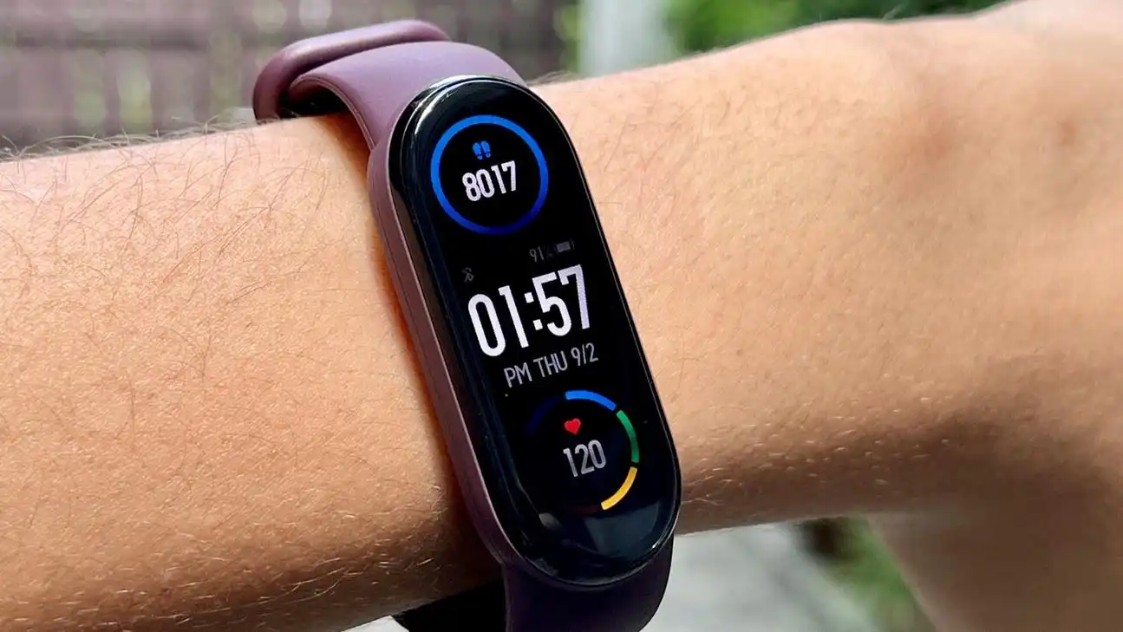

#### Figure 1 : Mi band

The Mi Band 6 is a popular smart health bracelet developed by Xiaomi. It is the latest model in the Mi Band series, released in 2021, and has gained a reputation for its impressive specifications. One of the Mi Band 6's most notable features is its large 1.56-inch AMOLED display with a resolution of 152 x 486 pixels. This is a significant upgrade from its predecessor, the Mi Band 5, which featured a 1.1-inch display. The Mi Band 6's larger display gives users more screen real estate to view health and fitness data, notifications, and other information. *(Android Authority, 2022).*

Xiaomi Mi Band 6 tracks all basic metrics like steps taken, active and resting heart rate, distance traveled, calories burned, sleep and 30 specific exercises (up from 11 last year). These exercises range from basics like running and cycling to niche activities like rowing, badminton, and HIIT.*(XDA Developers, 2021)*

Besides fitness tracking, the Mi Band 6 has several other features that make it a versatile smart health bracelet. It has a sleep tracking feature that monitors a user's sleep patterns and provides insight into sleep quality. The device can also be used to control music playback on connected devices, receive notifications from smartphones, and monitor menstrual cycles for female users.

Overall, the Mi Band 6 is an impressive smart health bracelet that offers a range of features that allow users to monitor and improve their health and fitness. Large displays, long battery life, and a wealth of fitness tracking modes make them popular with consumers looking for a reliable and versatile wearable device. 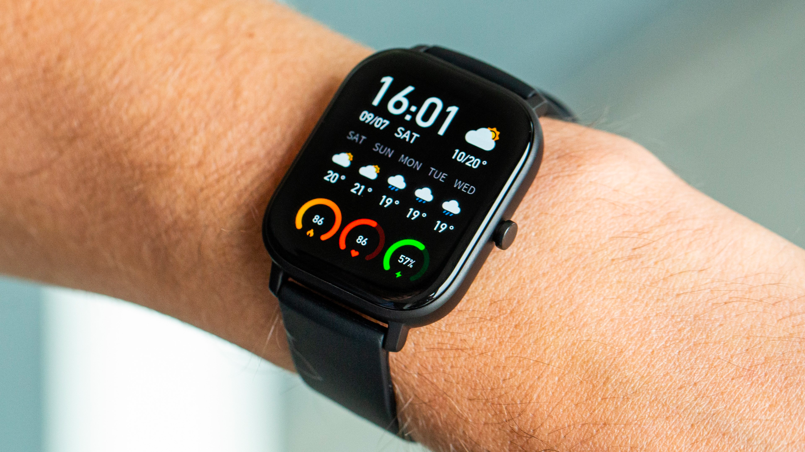

#### Figure 2 : Amazfit GTS

The Amazfit GTS is a smartwatch from Chinese electronics group Huami. It features a 1.65-inch AMOLED display with a resolution of 348 x 442 pixels and an always-on display. The watch has a slim 9.4mm aluminum alloy case and a 20mm interchangeable strap. Amazfit GTS is also 5ATM waterproof, making it suitable for swimming and water sports.

In terms of sensors, the Amazfit GTS includes a BioTracker PPG optical tracking sensor, a 6-axis accelerometer, a 3-axis geomagnetic sensor, a barometric pressure sensor and an ambient light sensor. This array of sensors allows the watch to track various fitness and health data. Additionally, the watch is equipped with Bluetooth 5.0 BLE and GPS+GLONASS connectivity, with NFC support on select models.

Amazfit GTS is equipped with a 220mAh lithium-ion polymer battery that can last up to 14 days on a single charge. In simple watch mode, the battery lasts up to 46 days on a single charge. With heart rate monitoring, sleep monitoring, and 12 different sport modes, this watch is perfect for fitness enthusiasts looking to track their workouts and overall health. In addition, the watch offers call and message notifications, music control, weather forecast, alarm clock, stopwatch, and find my phone.

Overall, the Amazfit GTS is a versatile smartwatch that can be used for many purposes. It's lightweight, stylish, and comes with a long-lasting battery that's perfect for on-the-go use. With comprehensive health and fitness tracking features and other useful features like call and message notifications, the Amazfit GTS is a great option for those who want a watch that can do it all.

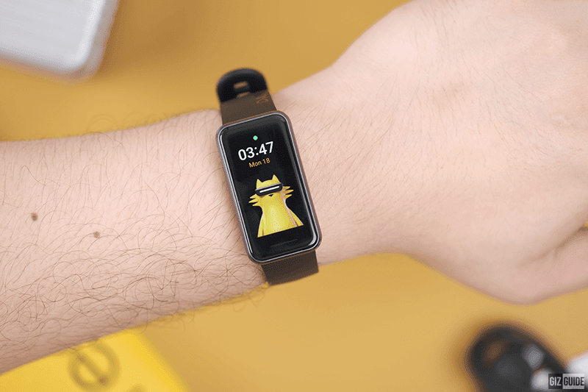

#### Figure 3 : Realme band 2

The Realme Band 2 is a fitness tracker from Chinese smartphone maker Realme. It features a 1.4-inch color touchscreen display with a resolution of 167 x 320 pixels and offers a large, easy-to-use interface for fitness tracking. The device is equipped with a 3-axis accelerometer, heart rate sensor, and blood oxygen (SpO2) sensor to track various health and fitness metrics.

Realme Band 2 comes with a 204mAh battery that lasts up to 12 days on a single charge, making it ideal for long-term use without frequent charging. It also has Bluetooth 5.1 for wireless connectivity and can be paired with Android and iOS devices via the Realme Link app. For those who enjoy water sports and activities, Realme Band 2 is IP68 water and dust resistant. This allows it to be submerged in water up to 1.5 meters deep for up to 30 minutes without damage.

When it comes to health and fitness tracking, Realme Band 2 offers comprehensive features such as heart rate monitoring, sleep tracking, blood oxygen monitoring, step counting, distance traveled, and calories burned. It also includes 90 selectable sport modes that provide real-time workout tracking.

In addition to health and fitness tracking features, the Realme Band 2 has some other useful features. These include call and message notifications, music control, camera control, weather forecast, and find phone.

Overall, the Realme Band 2 is an affordable, feature-packed fitness tracker that offers excellent value for money.It features a large color touchscreen display, long battery life, and comprehensive health and fitness tracking. This makes it a great choice for those looking for an affordable, high-performance fitness tracker.

#### Table 1 : The Comparison Of The Existing System

|  |  |  |  |
| --- | --- | --- | --- |
| **Smart health bracelet name** | **Advantages** | **Disadvantages** | **References** |
| Mi band 6 | Way affordable compared to other devices    Lightweight and very comfortable to wear for long periods time    Includes a Sp02 sensor for blood oxygen level monitoring | Comes with smaller display compared to the Amazfit GTS and Realme Band 2    Battery life span is shorter compared to the Amazfit GTS and Realme Band 2. | *(Paradiso et al., n.d.)* |
| Amazfit GTS | Larger, higher quality AMOLED display compared to other devices    Comes with more sensors such as barometric pressure sensor and geomagnetic sensor | More expensive compared to other devices stated    Larger and heavier compared to other devices | *(Amazfit GTS User Manual, n.d.)* |
| Realme band 2 | Larger display compared to the Mi Band 6  Includes a Sp02 sensor for blood oxygen level monitoring  Comes with longer battery life compared to the Mi Band. | Display quality is lower compared to the Amazfit GTS and Mi Band 6    No GPS or NFC support for mobile payments |  |

#### Table 2 : The Comparison Of Existing Arduino Health Monitoring Bracelets

|  |  |  |  |
| --- | --- | --- | --- |
| Arduino Project | Advantages | Disadvantages | References |
| MyBotic Durian UNO  Smart Patient Monitoring System | Contains LCD display for displaying user health metrics.  Includes Sp02 sensor for blood oxygen level monitoring, including BPM monitoring.  Includes LM35 Temperature Module, which enables body temperature tracking.  Cheap and easy to build and assemble. | Does not have an emergency button.  Large in size. Lacks a battery to be fully portable and worn. | mybotic.com.my/patient-monitoring-system-with-blynk-durian-uno-enhancement-of-arduino-uno |
| Pulse Oximeter! Measure Heart Rate and Oxygen Saturation using Max30102, Arduino and OLED Display | Contains a similar LCD display to the MyBotic system.  Tracks and measures BPM and Sp02 levels.  Includes a push button that acts as a display navigator. | Lacks a temperature sensor.  Push button can be seen as unnecessary, and should’ve been used as an emergency button.  Unable to be worn, lack of a proper strap. |  |
| Heartbeat monitoring wrist band. Is it possible to make using MAX30102 module | Comes with similar heartbeat sensing capabilities as other Arduino projects.  Smaller LCD display that projects current wearer’s readings.  Smallest size footprint amongst the bunch. | No Sp02 sensor for blood oxygen level monitoring.  Lack of an emergency button.  Similar to the other Arduino projects, with no distinguishing feature. |  |

### 2.3 Health and Metric Bracelet

In recent years, there has been a growing popularity of health and fitness metrics in health bracelets. Wearable devices provide a practical and easily accessible means for individuals to track and assess their physical well-being and exercise performance. The present literature review aims to scrutinise multiple research studies that have investigated health and fitness metrics for health bracelets and their plausible influence on individual health outcomes.

Wang et al. (2016) conducted a study to assess the precision of heart rate monitoring across five distinct health bracelets. The research findings suggest that the heart rate readings obtained from the five different devices were consistent with those obtained from a medical-grade heart rate monitor, thereby demonstrating the potential of health bracelets to furnish precise heart rate information. Nevertheless, the research also revealed a decline in the precision of the health bracelets during periods of intense physical activity or in the presence of an elevated body mass index (BMI).

The study conducted by Shcherbina et al. (2017) aimed to assess the accuracy of heart rate measurement provided by seven frequently utilised fitness trackers. The study findings indicate that six of the devices demonstrated a precision level that was within 5% of the actual heart rate, while one device exhibited a deviation of up to 34 beats per minute. The current study highlights the importance of choosing a reliable device for monitoring physical activity to ensure accurate health and fitness assessments.

The aforementioned research indicates that health bracelets have the potential to furnish precise and dependable health and fitness measurements, specifically in the domains of heart rate surveillance and sleep monitoring. Furthermore, health bracelets have the potential to serve as a viable mechanism for enhancing physical activity and enhancing health results, particularly among the younger population. Nevertheless, the precision of health bracelets may be impacted by variables such as intense physical activity and elevated BMI, and the dependability of information can differ across different devices.

To sum up, health bracelets possess the capability to serve as valuable instruments for individuals to track their health and fitness metrics. Subsequent investigations ought to further examine the precision and dependability of health bracelet data, alongside the efficacy of health bracelets in fostering salubrious conduct and enhancing health consequences.

### 2.4 Types Of Smart Health Bracelet

The employment of intelligent health technologies to enhance healthcare results has garnered growing attention in recent times. A technology that has gained popularity is the health bracelet, a wearable device that monitors multiple health parameters and delivers instantaneous feedback to its users. This literature review aims to analyse the various categories of health bracelets and their potential advantages.

Ennafiri and Mazri (2017) have classified health bracelets as a type of Internet of Things (IoT) device. Wearable devices are engineered to gather information pertaining to an individual's well-being, encompassing metrics such as cardiac rhythm, arterial tension, and circadian rhythms. Subsequently, the information is conveyed to either a mobile application or a cloud-centric platform, where it can be scrutinised and employed to furnish individualised feedback to the user. According to the authors, health bracelets possess the capacity to transform healthcare through facilitating remote monitoring, timely identification of health concerns, and enhanced treatment outcomes.

Amrani et al. (2016) conducted a study that specifically examined the utilisation of health bracelets in the management of chronic illnesses. According to the authors' findings, health bracelets possess the capability to monitor medication adherence, track symptoms, and offer reminders to patients. The implementation of this approach has the potential to enhance patient outcomes and mitigate healthcare expenditures by averting hospital readmissions and other associated complications.

Kumar and Gupta (2017) conducted a study to evaluate the usability of health bracelets in the domain of fitness tracking. According to the authors' findings, health bracelets have the potential to serve as a viable tool for promoting physical activity among users, as they offer immediate feedback and facilitate goal-setting. Nonetheless, the research also revealed certain constraints of health bracelets, including precision concerns and battery longevity.

Wang et al. (2020) conducted a study to investigate the potential of health bracelets in relation to mental health. The study conducted by the authors revealed that health bracelets possess the capability to monitor various mental health indicators such as stress levels and sleep quality. The proposition is made that health bracelets possess the potential to offer timely intervention and avert mental health emergencies.

To sum up, health bracelets exhibit potential as a technological tool to enhance healthcare results. Wearable devices have the potential to serve various purposes such as remote monitoring, chronic disease management, fitness tracking, and mental health monitoring. Notwithstanding, certain constraints remain unresolved, including concerns regarding precision and the longevity of battery performance. Additional investigation is required to comprehensively comprehend the capabilities of health bracelets and to redress these constraints.

### 2.5 Technology and Innovation Health Bracelet

Health bracelets are becoming increasingly popular among individuals who want to monitor their health and fitness levels. These bracelets are equipped with various sensors and technologies that enable users to track their heart rate, steps taken, sleep quality, and other vital health data. The aim of this literature review is to examine the current state of technology and innovation for health bracelets, including their design, functionality, and effectiveness.

The design of health bracelets has evolved over the years, from basic pedometers to sophisticated smartwatches with advanced sensors and features. The current generation of health bracelets is sleek, lightweight, and customizable, with options for different sizes, colours, and materials. According to Pataranutaporn, P. (2020) ,health bracelets are designed to be worn on the wrist, and they should be comfortable and unobtrusive. The authors also emphasise the importance of the bracelet's display, which should be easy to read and intuitive to use.

The functionality of health bracelets is what sets them apart from traditional wristwatches and pedometers. Most health bracelets are equipped with accelerometers, gyroscopes, and heart rate monitors that enable users to track their physical activity and vital signs. In addition, many health bracelets come with companion apps that allow users to view and analyze their health data.

The effectiveness of health bracelets in promoting health and fitness has been the subject of much debate. Some studies have found that health bracelets can be effective in increasing physical activity and improving health outcomes (Finkelstein et al., 2016). A systematic review by Romeo et al. (2020) found that health bracelets can be effective in promoting physical activity and weight loss, but more research is needed to determine their long-term effectiveness.

In conclusion, health bracelets are a promising tool for promoting health and fitness, but their effectiveness is still the subject of much debate. The design and functionality of health bracelets have evolved significantly over the years, with sleek and customizable designs and advanced sensors and features. Innovations in AI and ML are also promising, as they offer the potential for personalized recommendations and coaching. However, more research is needed to determine the long-term effectiveness of health bracelets and to identify ways to improve their design and functionality.

# CHAPTER 3

## RESEARCH METHODOLOGY

### 3.1 Introduction

In today's fast-paced world, health and fitness have become essential components of a well-rounded lifestyle. Wearable devices, such as health bracelets, have gained significant popularity due to their ability to track various health parameters and provide valuable insights. The development of such a device requires a structured approach to ensure its success. Agile methodology, with its iterative and incremental nature, is a widely adopted framework that promotes collaboration, flexibility, and adaptability throughout the project lifecycle. A project lifecycle serves to ensure a group collaboration goes as smoothly and efficiently as possible by setting a series of planned phases in the project .This section of our thesis explores and explains how the Agile methodology acts as our chosen method in executing the Smart Health Monitoring Bracelet project, and discuss the principles of agile methodology when developing a health bracelet.

The implemented methodology of the project is the Agile methodology, which is an iterative and incremental approach to software and hardware development that prioritises adaptability, collaboration, and continuous improvement. Unlike traditional waterfall methods, agile methodologies emphasise customer collaboration, frequent feedback, and the delivery of working software in short development cycles called sprints. This methodology is preferred and chosen because it is most suitable to the desired goals and outcomes of the project, as the relies on implementing multiple functionalities and iterations into a single device.

Agile projects are divided into 5 phases, each with its specific objectives and deliverables. The phases are planning, design, development, testing, deployment and end evaluation testing.

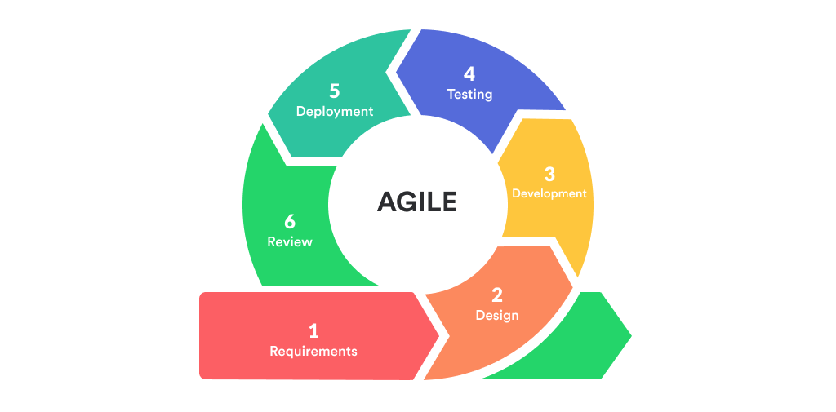

#### Figure 4 : Development Phases Agile Methodology

### 3.2 Description Of Development Phases

**3.2.1 Requirements**

Discovery and Requirements Gathering is an essential phase of the agile methodology in developing a health monitoring bracelet project. Our initial plan is to revolutionise the wearable devices that have emerged as valuable tools for monitoring and improving personal health thus this phase is essential in order to successfully implement agile methodology throughout the project lifecycle.

The Discovery and Requirements Gathering phase is the first step in an Agile project's lifecycle. Objective of this phase is to identify what needs, expectations, goals of the project. This phase set the stage for collaboration, communication and the sharing of concise project requirements, whilst also ensuring the understanding amongst the project members on what to do throughout the project.

In a project following the Agile Methodology, a user-centred approach is essential as it is the backbone on why the project was done in the first place. This involves conducting research and gathering user experiences to gain a deep understanding of the target audience. In the context of creating a health monitoring system bracelet, the team must identify what user‘s health needs and must desired functionalities and any potential that maybe they will be challenged. This information is critical for designing an effective user friendly product that is functional.

The Discovery and Requirements Gathering phase allows the project team to iteratively design and develop prototypes of the health bracelet. The agile methodology emphasises early and continuous feedback enabling the team to make additional necessary adjustments throughout the process . In the design review and testing, the team can refine what needs for product requirements and ensuring that the final solution as well like their expectations

**3.2.2 Design**

As is the case with the vast majority of development projects, the first step is to go through an initial planning stage. This involves creating a blueprint of the specification documents, identifying the problem and the goals that need to be accomplished, gathering data, and getting ready for the subsequent stages of the cycle. The Health Monitoring System Bracelet project aims to provide wearers with active and accurate health metrics readings and additional features that can alert guardians in case of events.

During the requirement phase, information regarding the importance of health monitoring and essential medical baselines are studied. Post-requirement phase visions the Health Monitoring System Bracelet would be developed as a wearable Arduno device to measure and track the current heartbeats per minute (BPM), blood-oxygen levels (Sp02), body temperature, an emergency button to alert guardians, and fall detection to indicate guardians of a fall due to health complications. The project scope has been specified to target the population that are susceptible to or are already facing chronic heart disease.

Thus, a foundation is set on the hardware and software requirements to implement the features and serves as the main components of the project. These requirements are on what physical components and modules are needed in implementing the desired functionalities and capabilities of the bracelet. In addition to which languages, data layers, and services that are most suitable to be used. Through thorough considerations, a table of hardware and software requirements is prepared.

#### Table 3 : Hardware Requirement

|  |  |  |
| --- | --- | --- |
| No | Hardware Specification | Hardware used |
| 1. | Microcontroller | ESP32 Arduino WiFi Board |
| 2. | Sensors | 1. Heart Rate Pulse Sensor & Oximeter MAX30102 2. LM35 Temperature Sensor 3. MPU 6050 GY-521 3   Axis Gyro Accelerometer |
| 3. | Battery | 1. 3.7V 550mah LiPo battery 2. Battery Charger TP4056 |
| 4. | Additional Hardware | 1. Pushbutton 2. Velcro straps |

#### Table 4 : Software Requirement

|  |  |  |
| --- | --- | --- |
| No | Software Specifications | Justification |
| 1. | Blnyk | App Development: Blynk Android App |

**3.2.3 Development**

Following the preparation of the diagrams comes the concentration on developing the main designs and functions of the Smart Health Monitoring System Bracelet, which includes the main design of the bracelet

The circuit diagram depicts the smart health bracelet's actual components and connections. Sensors, microcontrollers, displays, power sources, and other hardware components are depicted. The circuit diagram aids in the comprehension of hardware architecture and the creation of electrical connections.

Various diagrams are used to demonstrate how the smart health bracelet system will work:

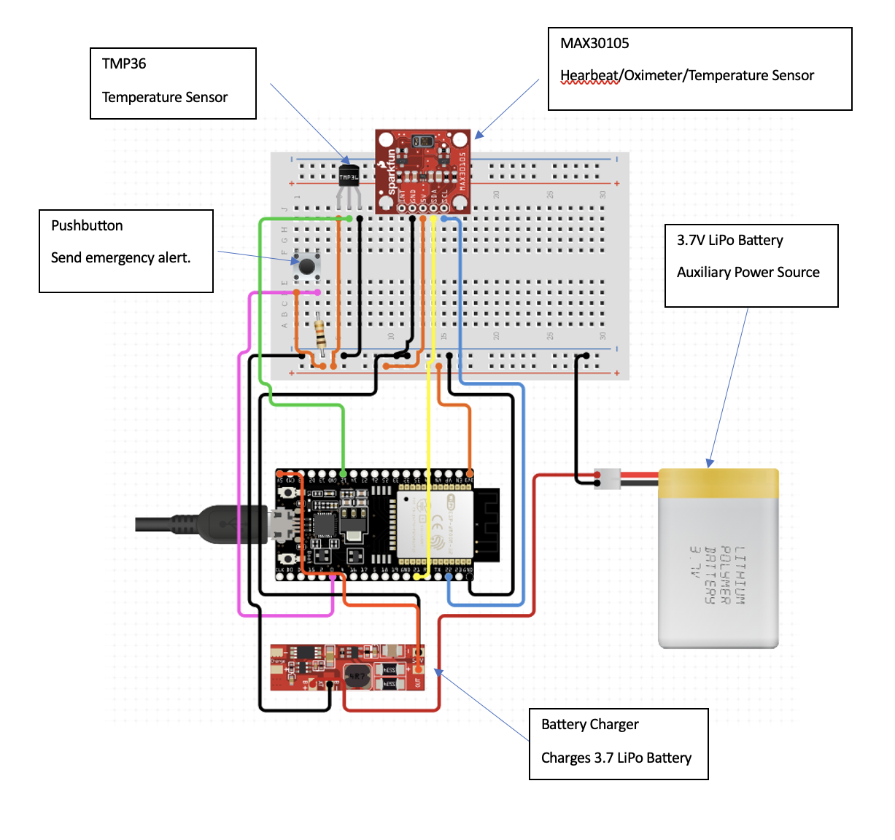

#### Figure 5 : Circuit Diagram

The flowchart graphic depicts the workflow and decision-making flow within the smart health wristband system. It depicts the steps involved, such as input acquisition, data processing, and generating the final result. The flowchart aids in understanding the system's logical flow and control structure.

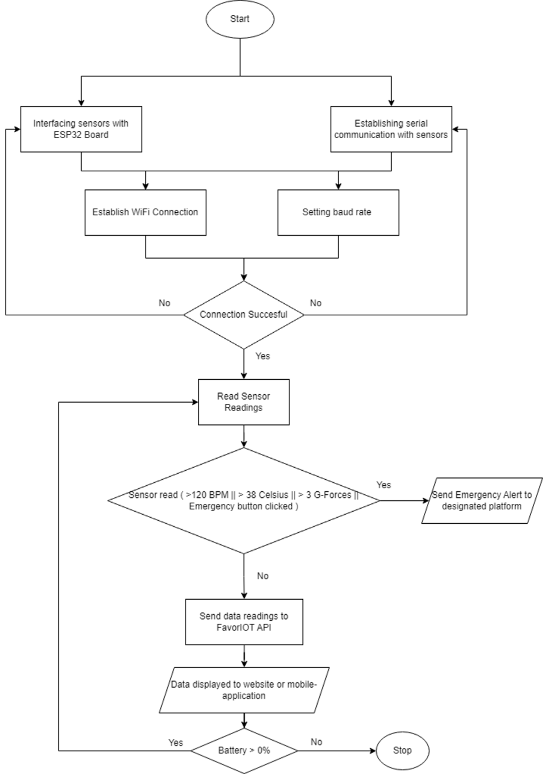

#### Figure 6 : Flowchart Diagram

In the main design of LifeGuardian, the ESP32 Arduino board acts as the main board that connects and receives health metrics data from the MAX30102 Heart Rate and Oximeter Sensor, MPU6050 Accelerometer, LM35 Temperature Sensor and pushbutton, and interprets the data into usable and viewable health information that is displayed onto a mobile phone using the Blynk IoT system. The entire system is powered by a 3.7V 550mah rechargeable battery.

After analysis and design, the project can begin coding and development. All planning, component specifications, and design documents for the project's first iteration, including the temperature sensor, heartbeat sensor, emergency button, heart rate monitoring, impact and fall detection, and notification functionalities, have been coded. The smart health bracelet will be implemented feature by feature, tested to assure stable functionality, and then integrated and combined into a cohesive, fully functional wearable health-band.

The project group will code each smart health wristband system component during implementation. This requires translating the design specifications of the temperature sensor, heartbeat sensor, emergency button, heart rate monitoring, impact and fall detection, and notification functionalities into a hardware and software-executable Arduini file. Coding standards and best practices ensure codebase maintainability, readability, and reusability.

The bracelet's hardware and code is integrated to collect temperature data for the temperature sensor implementation. The heartbeat sensor requires bracelet integration and coding to capture and analyse heart rate data. The bracelet's emergency button is programmed to deliver alerts and notifications. The heartbeat sensor continuously monitors the user's heart rate. The algorithm collects and processes heart rate data at regular intervals to offer real-time heart rate information. The bracelet implements motion sensor and accelerometers, and algorithms to detect and analyse impacts and falls. Developers test each unit or module throughout implementation. Unit testing tests inputs, outputs, logic, and algorithms. This procedure helps find and fix unit problems before integrating them into the system.

After unit testing, the smart health wristband system is connected and paired to a mobile phone using the Blynk IoT system. Integration testing verifies that the bracelet can pair and relay exact health readings to the paired mobile device. The integrated system is tested to assure compatibility and interoperability. In the development phase, unit testing, integration testing, and comprehensive testing guarantee that the smart health bracelet system meets requirements, functions as intended, and provides a dependable and seamless user experience.

### 3.2.4 Testing

The testing phase of the development of a smart health bracelet is an important step that must be taken in order to guarantee the device's capability, accuracy, and dependability in terms of measuring health and fitness data. During this phase, there are a variety of tests conducted to validate the performance and efficiency of the bracelet. The following is a list of important issues that should be taken into consideration during the testing phase for smart health bracelets

### 3.2.5 Deployment

The smart health bracelet is put through functional testing to ensure that it functions as intended, taking into account the functionality for which it was designed. This includes analysing each function and feature of the device, such as the temperature sensor, the heartbeat sensor, the emergency button, monitoring the user's heart rate, detecting impacts and falls, and receiving notifications. Test cases are developed to simulate a wide range of different possible scenarios and usage patterns. This is done in order to ensure that each and every feature and function works as intended.

Smart health bracelets include a number of sensors, such as the temperature sensor, heartbeat sensor, and impact detection capabilities, to collect accurate data relevant to an individual's health and fitness metrics. Some examples of these sensors include the temperature sensor, the heartbeat sensor, and the ability to detect impacts. It is absolutely necessary to do exhaustive testing on these sensors in order to guarantee both their accuracy and their dependability.

### 3.2.6 Review

Smart health bracelets are dependent on sensors in order to collect data linked to a person's health and fitness metrics. These parameters include heart rate, blood pressure, and steps taken each day. It is imperative to put these sensors through tests that evaluate not just their precision but also their durability. Because of this, it is necessary to compare the results obtained from the bracelet's sensors with those obtained from recognised measurement devices or well-established reference standards. Comparing something like a heart rate sensor, for instance, to a heart rate monitor that is intended for use in a medical setting is one way to ensure that the findings that the sensor provides are accurate.

### 3.3 Summary

In conclusion, Agile methodology was used in the development and evaluation of Agile Health Bracelet. The iterative and incremental approach allowed the development team to quickly respond to user feedback and continuously improve the device. The involvement of potential users throughout the process ensured that Agile Health Bracelet met their needs and preferences. The evaluation of the device provided valuable insights into its usability and effectiveness, and informed further design iterations. Overall, Agile methodology proved to be an effective and efficient approach for the development of Agile Smart Health Bracelet.

## CHAPTER 4

## Results and Discussion

### 4.1 Results

**Figure 7** shows the main dashboard that displays the current health metrics of the wearer. The wearer’s heart rate (BPM), and body temperature (Celcius) are displayed as a gauge for the current readings, in addition to a chart that shows the patterns of the readings.

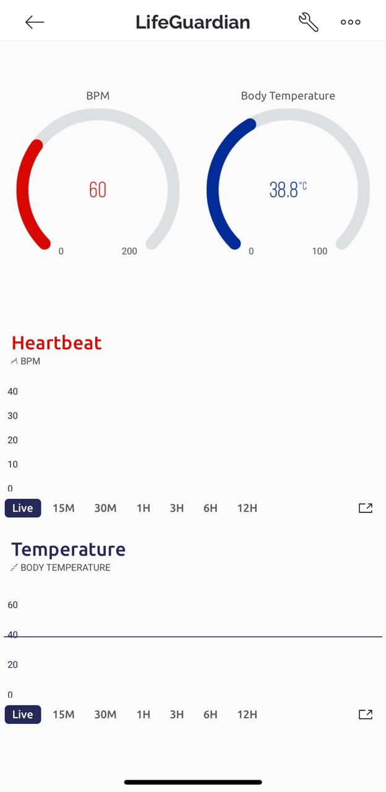

Figure 7 : Main dashboard

**Figure 8** showcases when the emergency button on the wearer's bracelet is pressed, a notification is triggered and sent to the Blynk API. This notification act as an alert, indicating that the wearer is in danger or requires immediate assistance. The Blynk API shows this notification by sending the emergency alert to wearer close contact and triggering predefined actions, ensuring a prompt response to the wearer's emergency situation. While, **Figure 9** showcases when the wearer experiences a fall, the sensor triggers a notification within the Blynk system. This notification act as an alert to inform the wearer close contact about the incident. By leveraging the sensor's capabilities, the Blynk API ensures prompt detection of falls and facilitates immediate communication to ensure the wearer's safety.

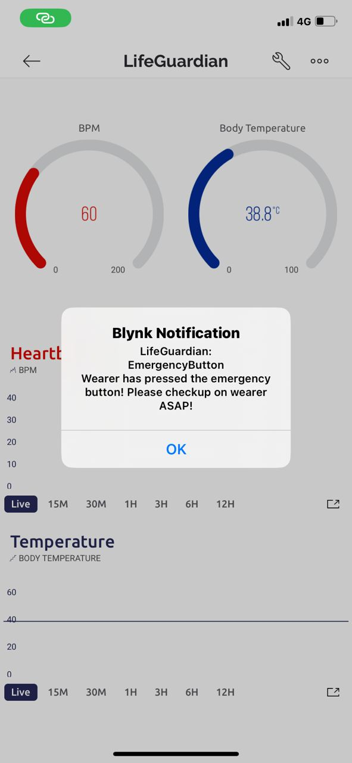

#### Figure 8 : Emergency Button Alert

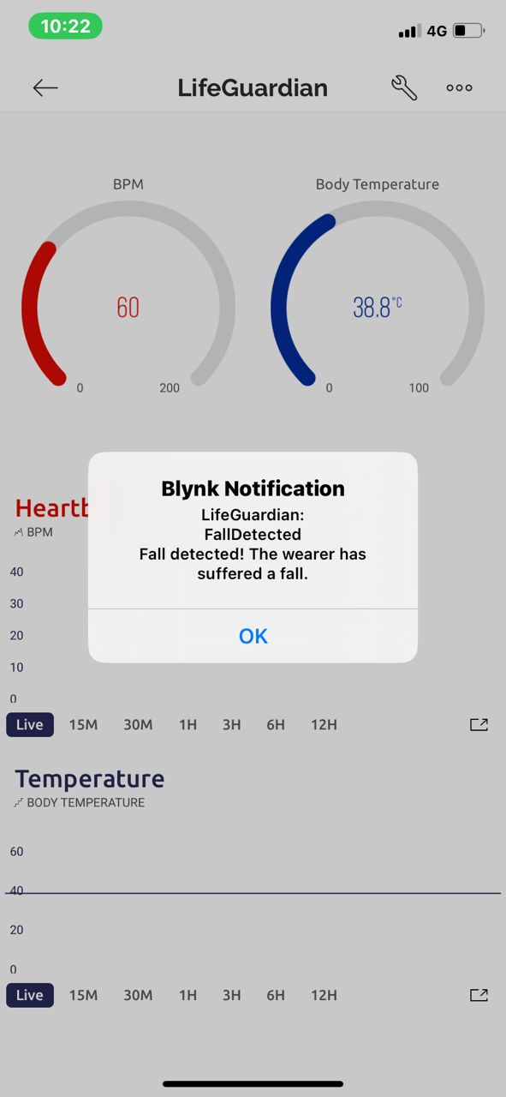

#### Figure 9 : Fall Detection Alert

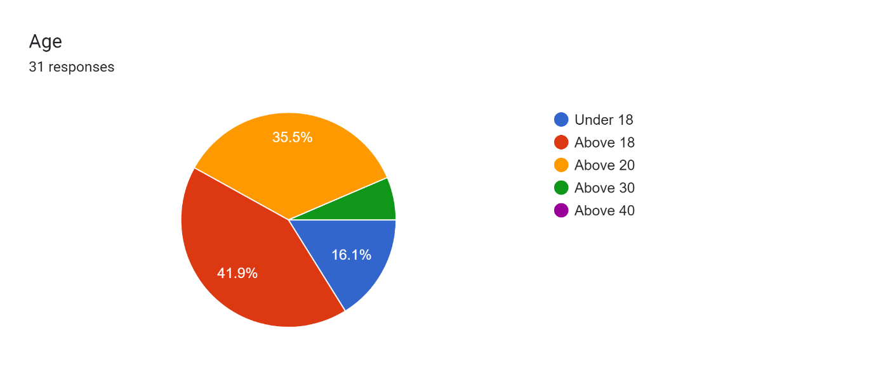

#### Figure 10 : Age Respondents

According to **Figure 10** below, the data provided, individuals under the age of 18 account for 16.1% of the respondents who filled out the form. This indicates that there is a significant portion of the population in the younger age bracket. Furthermore, those above the age of 18 make up 41.9% of the participants, suggesting a larger representation of adults in the survey

Additionally, when considering respondents above the age of 20, they comprise 35.5% of the total. This shows that there is a substantial number of individuals in their twenties who have taken part in the survey. Finally, the remaining percentage is allocated to those above the age of 30. Although the specific proportion is not provided, it can be inferred that the majority of respondents fall into this age group since it encompasses the leftover percentage.

Overall, based on the given data, it can be concluded that a significant majority of the individuals who filled out the form belong to the age group of adults. This suggests a potential focus on capturing the perspectives and insights of this specific demographic within the survey or study.

### 4.2 Discussions

The team engages in collaborative brainstorming sessions to identify areas where the bracelet's functionality, performance, and user experience can be further enhanced. Potential improvements may include the integration of additional health metrics, such as oxygen saturation or stress levels, or the exploration of advanced machine learning techniques to provide personalized health insights. By envisioning and discussing these future improvements, the project group aims to lay the groundwork for continuous innovation, ensuring that the LifeGuardian remains at the forefront of innovating the health monitoring technology and continues to make a positive impact on the lives of individuals susceptible to heart disease.

# CHAPTER 5

## CONCLUSION

### 5.1 Introduction

This chapter would conclude the overall process of the project. The idea of LifeGuardian: A Smart Bracelet for Elderly. This project focuses on taking pre-active steps into monitoring health through the use of a health monitoring bracelet, and its technical aspects. Therefore, this chapter would discuss the achievement, the constraints, and the improvement of the project in order to produce a greater outcome.

### 5.2 Project Achievement

After all the hard work to develop this project, the project finally achieves the goals of the objective stated earlier in this report.

**Objective 1: Develop a compact and wearable bracelet that will provide users an all-in-one device that can measure and track vital signs in real-time.**

The development of a compact and wearable bracelet that measures and tracks vital signs in real-time is an ambitious objective with immense potential. This all-in-one device will revolutionize health monitoring by offering portability, convenience, and comprehensive data analysis. By empowering individuals with real-time vital sign feedback, it can facilitate early detection of health issues, promote a proactive approach to well-being, and ultimately contribute to improved health outcomes.

**Objective 2: Design a bracelet that can sync with mobile devices, allowing users to view their health data, and receive alerts and notifications.**

the objective of designing a bracelet that can sync with mobile devices is to create a revolutionary wearable device that empowers users to monitor their health data, receive timely alerts and notifications, and make informed decisions regarding their well-being. By seamlessly integrating with mobile devices, this bracelet ensures optimal connectivity, enabling users to effortlessly access their health metrics, set personalized goals, and stay motivated. With its functional yet stylish design, this bracelet will become an essential companion for individuals striving to lead healthier and more balanced lives.

**Objective 3: To provide real-time health data and improve user outcomes by ensuring that users have access to accurate and up-to-date health data through a mobile application.**

The objective of providing real-time health data through a mobile application is a commendable endeavor that holds immense potential to transform healthcare delivery. Empowering individuals, facilitating early interventions, personalizing healthcare, promoting collaboration, and contributing to research are key outcomes that can be achieved by ensuring users have access to accurate and up-to-date health data. By harnessing the power of technology and data, this objective paves the way for a healthier future where individuals are empowered to make informed decisions and improve their overall well-being.

### 5.3 Value Added / Commercialization

1. Real-time health monitoring: Utilizing a heart rate sensor for accurate and precise monitoring of the wearer's heartbeat.

2. Fall detection: Capable of identifying and detecting instances when the wearer experiences a fall.

3. Emergency button: Sending instant notifications to the connected mobile phone upon activation of the emergency button on the bracelet.

### 5.4 Conclusion

In summary, the LifeGuardian smart bracelet is a valuable tool that promotes the safety, well-being, and independence of elderly individuals. This advanced wearable device incorporates various features and functionalities to ensure the safety and well-being of older adults.

# References

Fang, B., Sun, F., Quan, Z., Liu, H., & Shan, J. (2021, July 20). Smart Bracelet System for Temperature Monitoring and Movement Tracking Analysis. *Journal of Healthcare Engineering*, *2021*, 1–11. https://doi.org/10.1155/2021/8347261

Gimpel, A. S. (2022, January 1). *Репозиторий БГУИР: Smart health braceletes*. Репозиторий БГУИР: Smart Health Braceletes. https://libeldoc.bsuir.by/handle/123456789/47660

Siscoe, D. R. (n.d.). *Fitness trackers : understanding how user experience impacts motivation*. Fitness Trackers : Understanding How User Experience Impacts Motivation. http://cardinalscholar.bsu.edu/handle/123456789/201716

Mendoza, F. A., Alonso, L., López, A. M., & Sánchez And Patricia Arias Cabarcos, D. D. (2018, October 26). *Assessment of Fitness Tracker Security: A Case of Study*. MDPI. https://doi.org/10.3390/proceedings2191235

H., Fang, B., Sun, F., Quan, Z., Liu, H., & Shan, J. (2021, July 27). *Smart Bracelet System for Temperature Monitoring and Movement Tracking Analysis*. Smart Bracelet System for Temperature Monitoring and Movement Tracking Analysis. https://doi.org/10.1155/2021/8347261

Alugubelli, N., Abuissa, H., & Roka, A. (2022, November 17). *Wearable Devices for Remote Monitoring of Heart Rate and Heart Rate Variability&mdash;What We Know and What Is Coming*. MDPI. https://doi.org/10.3390/s22228903

Rutkowski, S., Buekers, J., Rutkowska, A., Cieślik, B., & Szczegielniak, J. (2021, April 13). *Monitoring Physical Activity with a Wearable Sensor in Patients with COPD during In-Hospital Pulmonary Rehabilitation Program: A Pilot Study*. MDPI. https://doi.org/10.3390/s21082742

Jones, E. K., Seki, L. A., & Mostul, C. J. (2017, April 16). *Prevalence and Use of Fitness Tracking Devices within a College Community*. DigitalCommons@Linfield - Linfield University Student Symposium: A Celebration of Scholarship and Creative Achievement: Prevalence and Use of Fitness Tracking Devices Within a College Community. https://digitalcommons.linfield.edu/symposium/2017/all/57

*Factors influencing on smart health | DBpia*. (2014, May 1). Dbpia. https://www.dbpia.co.kr/Journal/articleDetail?nodeId=NODE09236758

*amazfit.pdf*. (n.d.). Google Docs. https://drive.google.com/file/d/1c3QXeIIRuPtR4ReT8zn1YYs9W-wE5xGv/view?usp=sharing&usp=embed_facebook

PARADISO, C., COLINO, F., & LIU, S. (2020, May 1). *The Validity and Reliability of the Mi Band Wearable Device for Measuring Steps and Heart Rate*. PubMed Central (PMC). https://www.ncbi.nlm.nih.gov/pmc/articles/PMC7241628/

*weable heart rate monitoring intelligent sport bracelet based on internet of things.pdf*. (n.d.). Google Docs. https://drive.google.com/file/d/1nmhH3eq31wWiBV2aL79NY8F4zHclr3sx/view?usp=sharing&usp=embed_facebook

*smart health solution integrating iot and cloud.pdf*. (n.d.). Google Docs. https://drive.google.com/file/d/1fJu_b1D2xzRuuNilAtYOgj0t_M-DKjmH/view?usp=sharing&usp=embed_facebook

*iot of things for smart healthcare a review on a potential iot based system and thecnologies to control covid 19 pandemic.pdf*. (n.d.). Google Docs. https://drive.google.com/file/d/1XKBIabQLHiZlNhk-UQrJDLRTRn9bomXH/view?usp=sharing&usp=embed_facebook

*ai,iot and wearble technology for smart healthcare.pdf*. (n.d.). Google Docs. https://drive.google.com/file/d/1vvpCRSJZNL8ejexl4JYsX-xT6VmYduxP/view?usp=sharing&usp=embed_facebook

*accuracy of wrist worn heart rate monitors.pdf*. (n.d.). Google Docs. https://drive.google.com/file/d/1tIpoFQS3nM4iXrthhmI7QZLbEiJ_3Qfx/view?usp=sharing&usp=embed_facebook

*accuracy in wrist worn sensor based measurement of heart rate and energy expenditure in diverse cohort.pdf*. (n.d.). Google Docs. https://drive.google.com/file/d/1f_ZoThqINRlUll92xfKLHuN3VzrGs8X5/view?usp=sharing&usp=embed_facebook

Taber, J. M., Leyva, B., & Persoskie, A. (2014, November 12). *Why do People Avoid Medical Care? A Qualitative Study Using National Data - Journal of General Internal Medicine*. SpringerLink. https://doi.org/10.1007/s11606-014-3089-1

*Survey on IOT: Privacy and Security.pdf*. (n.d.). Google Docs. https://drive.google.com/file/d/1Lh1IKpurE48QNVtEKzlxx-7ZZrcZuDJe/view?usp=sharing&usp=embed_facebook

*Statistics on Causes of Death, Malaysia, 2021.pdf*. (n.d.). Google Docs. https://drive.google.com/file/d/1lSYi42s9K4138dGB85ogJEJdIOmzs_3-/view?usp=sharing&usp=embed_facebook

Saip, M. A., & Mohamed, A. S. (2018, January 1). *Smart Health Monitoring and Controlling using Raspberry Pi3 | IIRJET*. Smart Health Monitoring and Controlling Using Raspberry Pi3 | IIRJET. https://doi.org/10.32595/iirjet.org/v4i1.2018.70

H., Fang, B., Sun, F., Quan, Z., Liu, H., & Shan, J. (2021, July 27). *Smart Bracelet System for Temperature Monitoring and Movement Tracking Analysis*. Smart Bracelet System for Temperature Monitoring and Movement Tracking Analysis. https://doi.org/10.1155/2021/8347261

Maharajan, M. K., Rajiah, K., Fang Num, K. S., Yap, S. L., Ying Lau, S. H., Ngu, W. Y., & Ching, Y. Y. (2023, January 19). *Public Perception of the Risk of Heart Disease and Their Willingness to Pay for Its Diagnosis in Malaysia*. MDPI. https://doi.org/10.3390/jvd2010007

Buttar, H. S., Li, T., & Ravi, N. (n.d.). *Prevention of cardiovascular diseases: Role of exercise, dietary interventions, obesity and smoking cessation*. PubMed Central (PMC). https://www.ncbi.nlm.nih.gov/pmc/articles/PMC2716237/

*ACM Digital Library*. (n.d.). ACM Digital Library. https://dl.acm.org/doi/abs/10.1145/3342428.3342693

*Genetics in Cardiovascular Disease.pdf*. (n.d.). Google Docs. https://drive.google.com/file/d/1XvSwdHA8B82hGzjgsIwCsutojAEloVo2/view?usp=sharing&usp=embed_facebook

*Designing smart bracelet for old adults.pdf*. (n.d.). Google Docs. https://drive.google.com/file/d/1gPH6RZzK5uLFn7572JiqjhXagjRKvV9F/view?usp=sharing&usp=embed_facebook

**Appendix A : Required hardware and software for Lifeguardian**

Hardware:

1. Microcontroller:

|  |
| --- |
| ESP32 Bluetooth and WiFi |
|  |

1. Sensors:

|  |  |  |
| --- | --- | --- |
| Heart-Rate Pulse  Sensor & Oximeter  MAX30102 | LM35 Temperature Sensor | MPU 6050 GY-521 3  Axis Gyro  Accelerometer |
|  |  |  |

3. Battery:

|  |
| --- |
| 3.7V 1050mAh 803040 Lithium Polymer Li-Po ion  Rechargeable Battery For MP4 MP5 GPS PSP mobile Pocket |
|  |
| [https://shopee.com.my/3.7V-1050mAh-803040-Lithium-Polymer-Li-Po-ion-](https://shopee.com.my/3.7V-1050mAh-803040-Lithium-Polymer-Li-Po-ion-Rechargeable-Battery-For-MP4-MP5-GPS-PSP-mobile-Pocket-i.22727342.6121269171?sp_atk=318c17de-78cf-491a-9bb7-749853152a63&xptdk=318c17de-78cf-491a-9bb7-749853152a63)  [Rechargeable-Battery-For-MP4-MP5-GPS-PSP-mobile-Pocket-](https://shopee.com.my/3.7V-1050mAh-803040-Lithium-Polymer-Li-Po-ion-Rechargeable-Battery-For-MP4-MP5-GPS-PSP-mobile-Pocket-i.22727342.6121269171?sp_atk=318c17de-78cf-491a-9bb7-749853152a63&xptdk=318c17de-78cf-491a-9bb7-749853152a63)  [i.22727342.6121269171?sp_atk=318c17de-78cf-491a-9bb7749853152a63&xptdk=318c17de-78cf-491a-9bb7-749853152a63](https://shopee.com.my/3.7V-1050mAh-803040-Lithium-Polymer-Li-Po-ion-Rechargeable-Battery-For-MP4-MP5-GPS-PSP-mobile-Pocket-i.22727342.6121269171?sp_atk=318c17de-78cf-491a-9bb7-749853152a63&xptdk=318c17de-78cf-491a-9bb7-749853152a63) |

4. Additional Hardware

|  |
| --- |
| Starter Kit Set |
|  |
| https://shopee.com.my/Malaysia-stock-Electronic-Components-Breadboards-Starter-Kit-  Set-For-Arduino-Durable-Useful-Starter-kits-LED-buzzers-  i.48117981.12729484819?sp_atk=aa3097ea-9265-4964-b68f092aae27bbdb&xptdk=aa3097ea-9265-4964-b68f-092aae27bbdb |

Software:

1. App Development: Blynk Android App

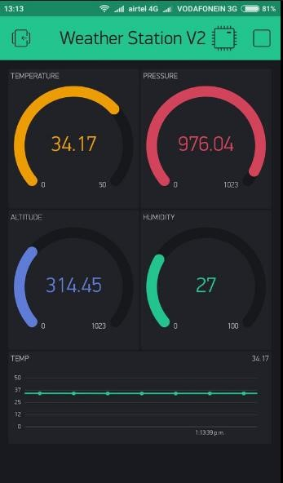

**Appendix B : Gantt Chart**



**Appendix C : Google Form**



